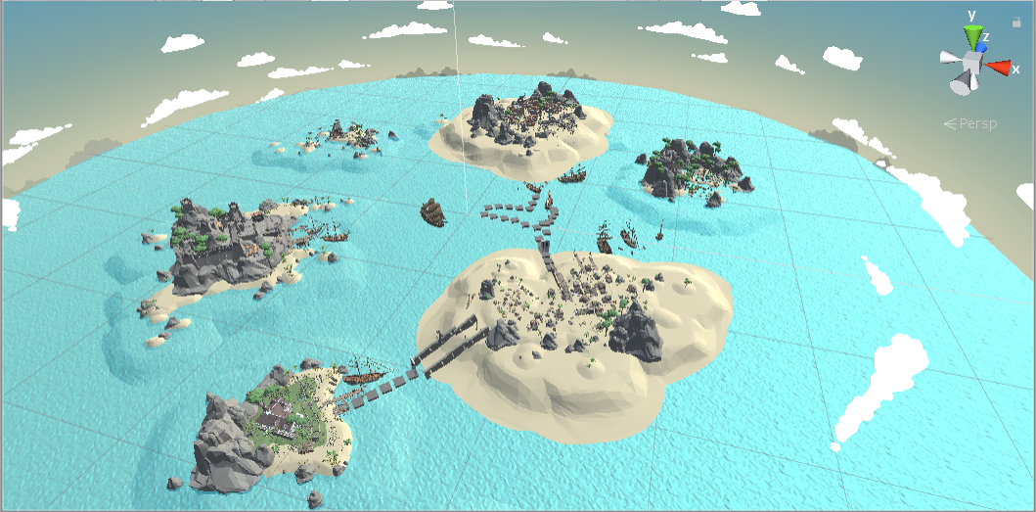

Welcome to my game! Here you will enter an unknown adventure world.

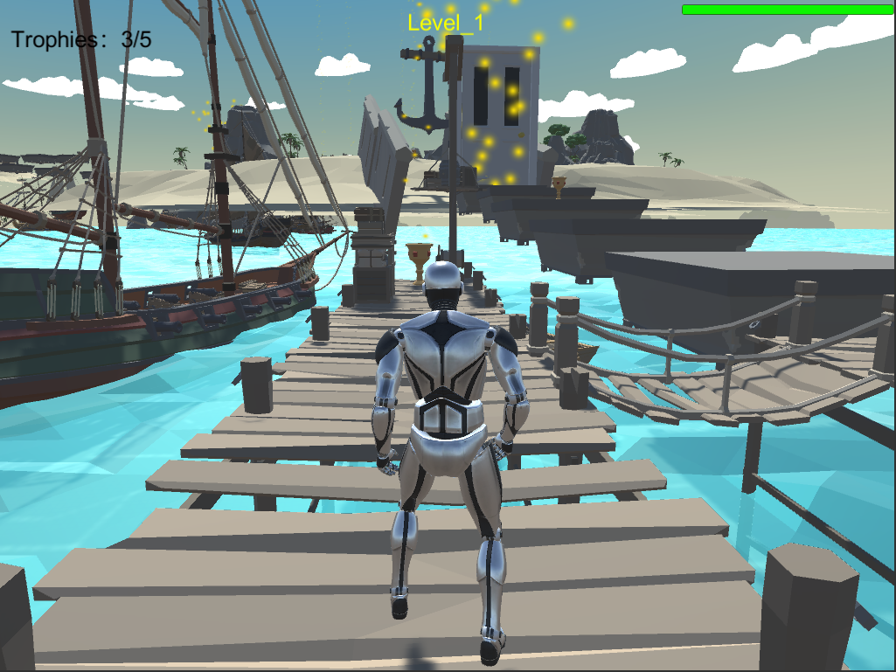

You can control your role to go to anywhere. Your goal is to find the lost scroll. There are total three levels. In level 1 and level 2, you have to collect all 5 trophies to enter to the door, then you will go to next level.

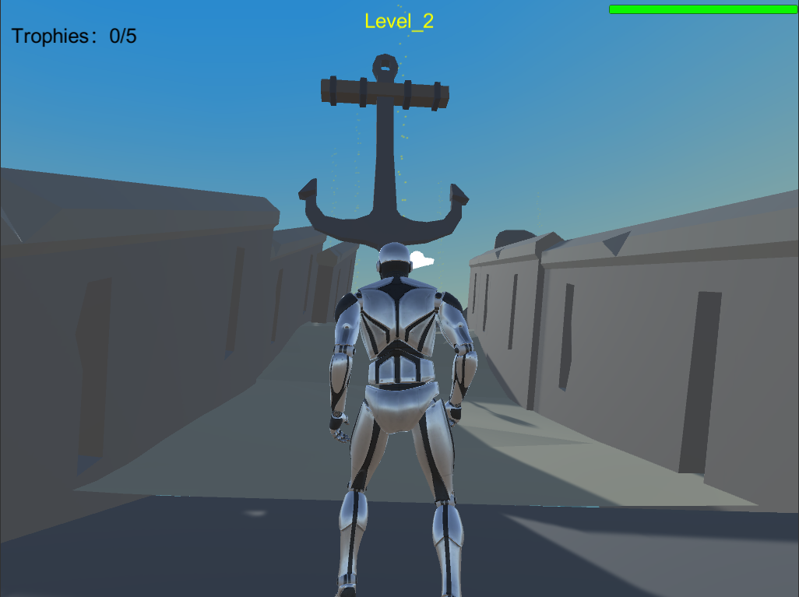

Watch out for these moving blades. If you get touched by them, you will die immediately.

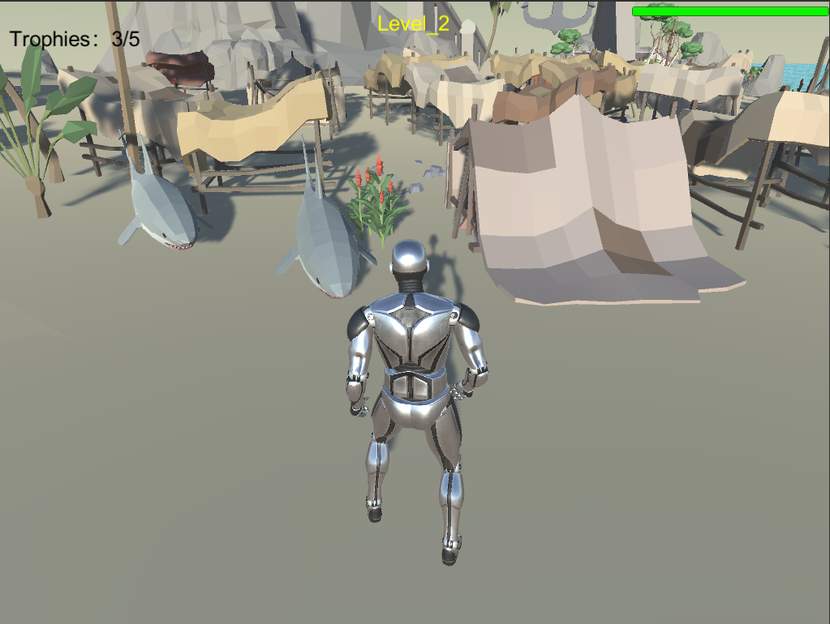

Watch out these sharks. They are dangerous and moving fast. You will lose health if you get attacked by them.

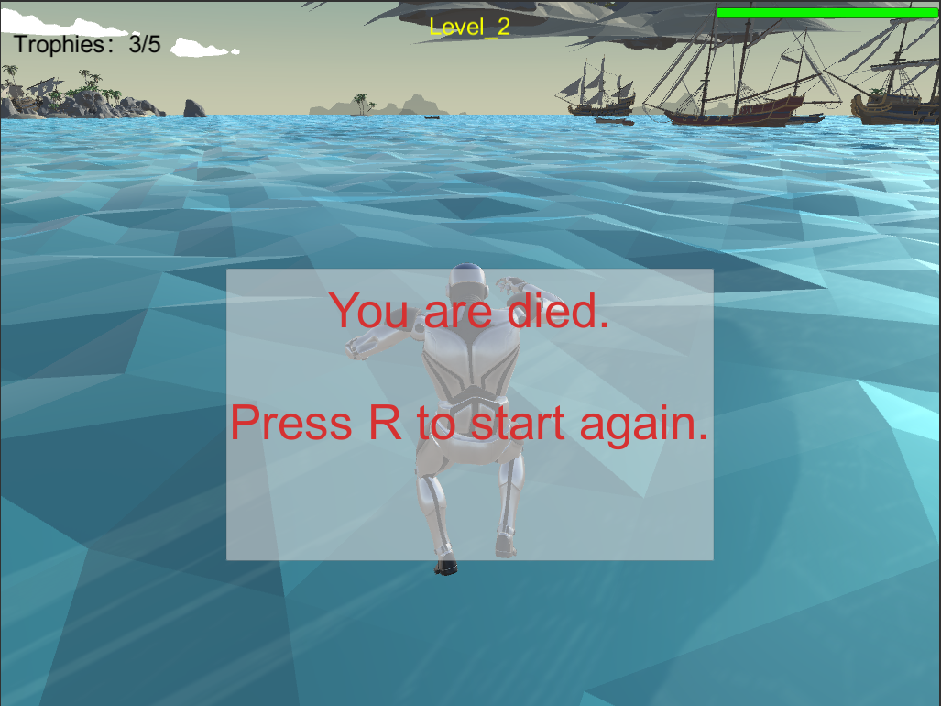

Every time you die, you can press R to start again this level.

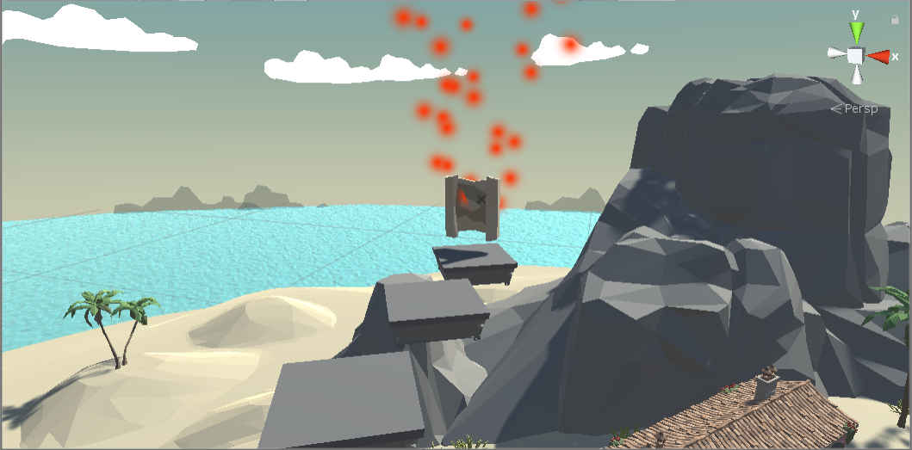

Once you get the lost scroll at the end of level 3, you win the game.